MATH 6/7 SYLLABUS 2019 - 2020
Mrs. Grogan
Welcome to 6th Grade Accelerated Math! I look forward to working with each of you.
I know we are going to have an exciting, interesting, and fulfilling year together. This is OUR classroom. We are a team. We must work together in order to achieve our goals. My goals are to teach you the Georgia Standards of Excellence, provide a safe, nurturing, and interesting environment, and get you to LOVE MATH as much as I do. Your goals should be to succeed in math, get along with your peers, and to come to class prepared with a positive attitude. I have high expectations for all of you. I know we are going to have a fantastic year together!
I believe that clear guidelines will prevent future problems and miscommunications throughout the school year. Rules provide a safe and effective learning environment and procedures are necessary for an efficient, well-managed, and organized classroom. Behavior rewards will be given to reinforce positive behaviors and behavior consequences will be administered according to Barber’s Warrior Way policy.
By the end of the year, students in this course will have covered the entire 6th grade math curriculum, as well as the first half of the 7th grade math curriculum. Math 6/7 students will: understand the four arithmetic operations as they relate to rational numbers, including signed numbers; compute with different forms of rational numbers; understand the concept of ratio and solve problems using proportional reasoning; determine the surface area and volume of solid figures; and use variables to represent unknown quantities in formulae, algebraic expressions, equations, and inequalities. You will find all relevant standards at
https://www.georgiastandards.org/Georgia-Standards/Pages/Math-6-8.aspx

Accelerated Placement
The course framework and instructional strategies for this course are differentiated in content, pacing, process skills emphasis, and expectation of student outcomes from the typical 6th grade math course. Course content has been designed for mastery and extension of state and district performance standards. The course is appropriate for students who have high achievement and interest in math. Barber Middle School has established criteria and guidelines to identify students who will be successful in this course. Students are placed in this class according to specified indicators of demonstrated exceptional ability and motivation. Students must meet continuation criteria to remain in the class.
Students must maintain an 80% average to continue on the advanced content track. Students must have an 80% average by the end of each quarter (9 week grading period), or the student will be placed on probation. This probation continues for at least 9 weeks with an intervention plan developed and implemented. If the grade remains below an 80% following probation and intervention, continued placement may be affected.

Grading
40% - Formative Assessments (Daily Work, other non-test assignments)
60% - Summative Assessments (CTLS Assessments, Tests, Performance Tasks, Weekly Homework)
***Please check ParentVue for student’s grades***

Math 6/7 Pacing Guide
Semester One:
Unit 1: Number System Fluency
Unit 7: Rational Explorations
Unit 8: Operations w/ Rational Numbers
Unit 3: Expressions
Unit 4: 1-Step Equations & Inequalities
Unit 9: Expressions & Equations
Unit 2: Rate, Ratio & Proportional Reasoning
Semester Two:
Unit 10: Ratios & Proportional Relations
Unit 5: Area & Volume
Unit 6: Statistics
Unit 11: Review & Extend (we will revisit inequalities, equations, ratios & proportions)

Work Policy
All assignments are due at the beginning of class, on the due date given. Assignments will not be accepted late. When a student does not have their work, the student will submit a sheet of paper with the following information:
- Name (first and last)
- Period
- Date
- Name of Assignment
- Why the assignment was not completed/turned in
- Parent’s name
- Parent’s best contact number
If the student is absent, the due date will be extended one day for every day the student is out. If there are extended absences, please contact me to arrange a plan to stay on track.
Assignments without work will be returned to the student with a score of zero. The assignment can then be completed with work shown. Once resubmitted, the assignment will be regraded for full credit. If the student continues to turn in assignments without work, I will contact home.
Homework Policy
Homework is given on a weekly basis to allow time for students to ask questions, seek tutoring, and plan around family events. Each homework assignment is approximately 20 – 25 problems in length and are designed to practice skills previously taught. Application of those skills will happen in the classroom. Homework will be issued every Friday (except before week long breaks) and will be due the following Friday. Please do not wait until the morning the assignment is due to tell me you did not understand or need help. That is why you have a whole week to work on the assignment.

Grade Recovery Policy
Assignments/Homework
In the event a student does not obtain an acceptable grade on an assignment he or she will be given the opportunity to rework the incorrect problems to demonstrate a better understanding of the content and achieve a higher score. In order to rework an assignment, the student needs to:
  - Copy missed problems to a separate sheet of paper. Please do not erase the original work!
  - Rework the problems, showing all work.
  - Staple corrections to the front of the assignment.
  - Place back in the correct turn in bin for your class period.
Failure to follow procedures will result in me returning the corrections ungraded. Each assignment may only be corrected one time. All corrected problems will be regraded for full credit.
Tests/Quizzes
Retakes will be given in class before the end of the current grading period. Retakes will not take place immediately. Students need time to study or seek out tutoring before re-testing. The retest will always be a different assessment but with the same type of problems as the original.

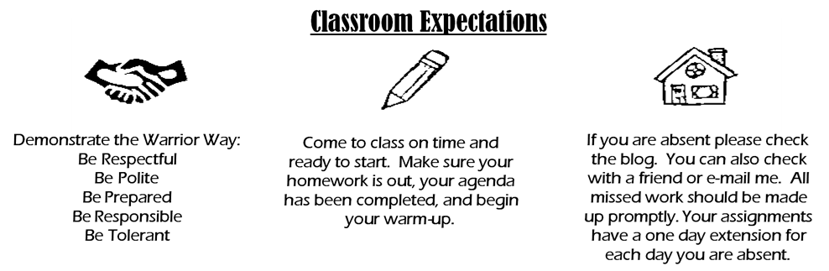
Textbook
There will not be a textbook this school year. The county adoption for math textbooks in middle school ended at the end of last school year. Our “textbook” will be our MSG (Math Survival Guide). Please see below.

Math Survival Guide
The purpose of the Math Survival Guide (MSG) is to enable students to be independent thinkers and writers. Math Survival Guides (MSG) will be used for class notes as well as for other activities in which students will be asked to express their own ideas and process the information presented in class. Students will be expected to maintain this organizational tool throughout the year.

Supplies For Class
**Item needs to be replenished throughout the school year
- Scientific Calculator (TI-30SX II or equivalent) – no graphing calculators
- One 3-Prong Folder with Pockets
- Non-Black checking pen
- Colored Pencils
- Ruler
- Highlighters (Yellow, Orange, Pink, 4th color of your choice/finding)
- Scissors
- Glue Sticks (large, several throughout the year)
- Pencils and Erasers**
- Composition Notebook (2) - any color, 100 pages (please no spirals)
- Loose Leaf Paper**

Optional supplies: Please consider donating any of the following if you are able.
- Tissues
- Paper Towels
- Pencils
- Hand Sanitizer
- Clorox/Lysol Wipes
- Band-Aids

SYLLABUS RECIEPT FOR MATH CLASS
Guardians: Please check the boxes to the left indicating your agreement to the following:
- I have reviewed the class syllabus and understand the grading and work policies.
- I understand that my child must adhere to all policies and procedures provided in the Barber Middle School Handbook and CCSD policies and procedures not mentioned in this syllabus.
- I will seek access to ParentVue and check my child’s grades/progress regularly.
- I understand that my child must have an 80% average or higher at the end of each quarter.

Parent/Guardian Name (Please Print): _____________________________________________________

Parent/Guardian Signature: ______________________________________________________________

Date: ______________________

Students:
- I have reviewed the syllabus and understand the grading policy.
- I understand the work and due date policies.
- I understand that I must adhere to all policies and procedures provided in the Barber Middle School Student Handbook and CCSD policies not mentioned in this syllabus.
- I understand that my time in the classroom is a time to educate and advance my early career; I will do my best every day to make sure that I am prepared, I’ve completed and submitted all assignments on time, and that I contribute as much as I can to the learning environment.

Student Name (please print): ____________________________________________________________

Student Signature: _____________________________________________________________________

Date: _______________________

