Math 7/8
Unit 8 Linear Functions
Volume 1 Issue 8
References  Glencoe/McGraw-Hill Georgia Math Grade 8 Volume 2, Chapter 7 Lessons 4-10  Glencoe/McGraw-Hill Georgia Math Grade 8 Text Online:  connectED.mcgraw-hill.com  Learning Links: https://my.hrw.com/math11/math06_07/nsmedia/lesson_videos/alg1/player.html?contentSrc=6344/6344.xml  https://my.hrw.com/math11/math06_07/nsmedia/lesson_videos/alg1/player.html?contentSrc=7506/7506.xml  http://mathbitsnotebook.com/Algebra1/LinearEquations/LELineEquations.html  http://mathbitsnotebook.com/Algebra1/LinearEquations/LEGraphiLines.html  https://my.hrw.com/math11/math06_07/nsmedia/lesson_videos/alg1/player.html?contentSrc=6347/6347.xml | Dear Parents  Below you will find a list of concepts that your child will use and understand while completing Unit 5 Linear Functions. Also included are references, vocabulary and examples that will help you assist your child at home.  Concepts Students will Use and Understand  - Graph proportional relationships  - Interpret unit rate as the slope  - Use similar triangles to explain the concept of slope  - Derive the equation y=mx and y=mx+b  - Interpret equations in y=mx+b form as linear functions  Vocabulary  - Intersecting Lines: Two lines that cross each other. Lines intersect at one point unless the lines fall directly on top of each other (in which case they are essentially the same line and are sometimes called coincidental).  - Origin: The point of intersection of the vertical and horizontal axes of a Cartesian plane. The coordinates of the origin are (0, 0).  - Linear Functions: functions that form a straight line  - Proportional Relationships: A relationship between two equal ratios.  - Slope: The "steepness" of a line. The slope of a line can be found directly when a linear equation is in slope-intercept form (y = mx + b). In this form, the slope is the coefficient of x and is represented by the letter m. The slope of a line can also be found by determining the ratio of the "rise" to the "run" between two points on the graph. In other words, slope measures how much the line rises vertically given a particular run or horizontal distance.  - Slope-Intercept Form: y=mx+b where m represents the slope and b represents the y-intercept  - Unit Rate: A comparison of two measurements in which the second term has a value of 1. Unit rates are used to compare the costs of items in a grocery store.  - Y-intercept: where a line crosses the y-axis on the coordinate plane  Try: http://intermath.coe.uga.edu/

 | Math 8 Unit 5 Practice Problems
Formulas  Slope (m)  m=  Slope-Intercept Form  y = mx+b  Y-intercept (b); (0,b) | Example 1  What is the slope of the function? What is the y-intercept? Write the equation of the line in slope-intercept form. Is this a linear function? Why?  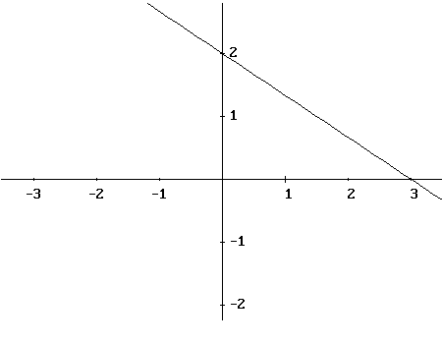  Example 2  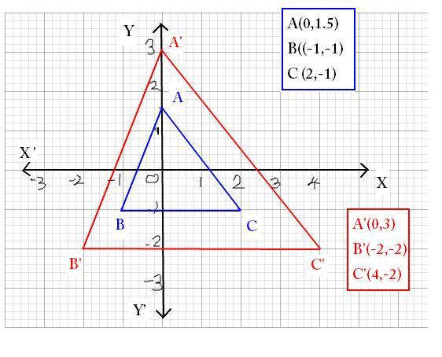What is the slope of and ?
Key
Example 1

Slope (m) = -2/3 Y-intercept (b)= 2

Equation of the line: y = -2/3x +2

Yes, it is a linear function because every input has exactly one output and the line is linear.

Example 2
The slopes are the same: 5/2 or 2.5; Similar triangles will have like sides proportional with the same slope.

