**Volume 1, Issue 9**

Math 6/7 Unit 9

Expressions & Equations

Dear Parents,

Below is information regarding Unit 2, Expressions & Equations. Look for additional information for future units.

# Expressions & Equations

*By the end of this unit, students will understand that:*

* Variables can be used to represent numbers in any type mathematical problem.
* Understand the difference between an expression, an equation, and an inequality.
* Expressions are simplified and equations are solved for the variable’s value.
* Write and solve multi-step equations including all rational numbers.
* Expressions, equations, and inequalities can be used to represent and solve real world problems

**Vocabulary**

**Algebraic Expression:** an expression consisting of at least one variable and also consists of numbers and operations

**Numerical Expression:** an expression consisting of numbers and operations

**Coefficient**: the number part of a term that includes a variable. For example, *3* is the coefficient of the term *3x*

**Constant:** a quantity having a fixed value that does not change or vary, such as a number. For example, *5* is the constant of *x + 5*

**Equation:** a mathematical sentence formed by setting two expressions equal

**Inequality:** a mathematical sentence formed by placing inequality symbols ( >,<,≥,or ≤) between two expressions.

**Term:** a number, a variable, or a product and a number and variable.

**Variable:** a symbol, usually a letter, which is used to represent one or more numbers.

*Try:* [*http://intermath.coe.uga.edu/*](http://intermath.coe.uga.edu/)

## Textbook Connection

**McGraw Hill Georgia Math 6 Plus**: Chapter 10 Lessons 1-6; Chapter 11 Lessons 1-8

Web Resources

<http://www.purplemath.com/modules/solvelin.htm>

<http://www.algebralab.org/lessons/lesson.aspx?file=algebra_onevariabletwostep.xml>

<https://www.ixl.com/math/grade-7/solve-two-step-equations>

<http://www.mathgoodies.com/lessons/vol7/equations.html>

<http://www.math.com/school/subject2/lessons/S2U1L3GL.html>

<http://www.math.com/school/subject2/practice/S2U1L3/S2U1L3Pract.html>

<http://www.homeschoolmath.net/teaching/teach-solve-word-problems.php>

<http://www.aaamath.com/equ725x7.htm>

<http://education.jlab.org/sminequality/index.html>

MC900233968[1]

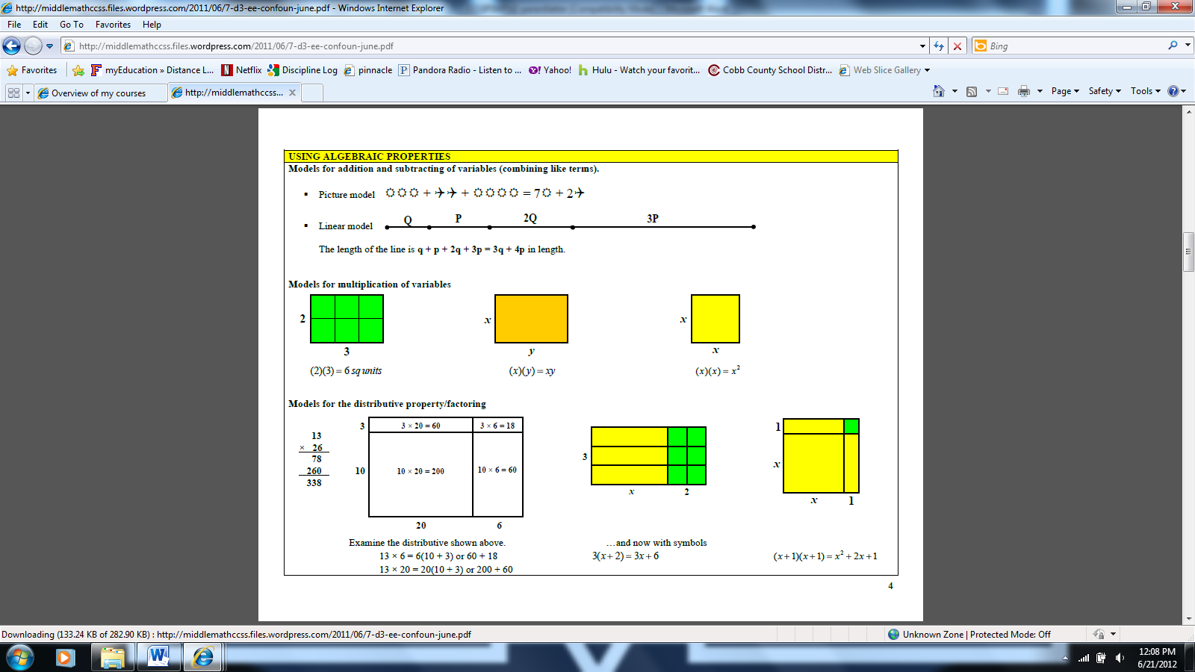

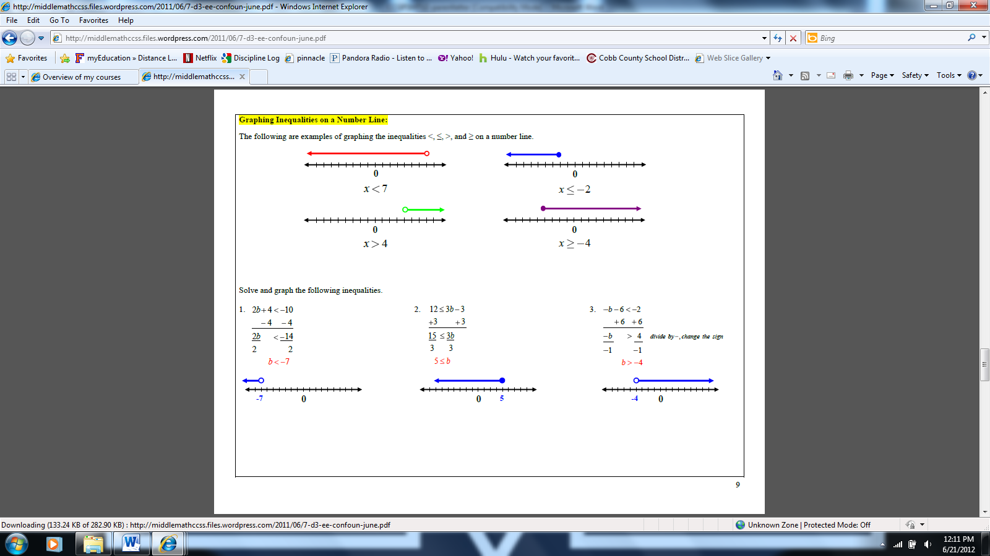

**Ways Parents Can Help**

Here are some activities you and your student can do together:

* Look for situations that can be represented as algebraic expressions. For example, if hotdogs are sold in packs of 8, an expression that shows the number of hotdogs in *h* packs would be 8*h*.
* Sort household items making sure only items that are alike are grouped together. Represent the groups with algebraic expressions. For example, 6T might represent 6 tablespoons and 4P might represent 4 plates. You cannot combine 6T and 4P because they have different variables.
* Write and solve equations that address such questions as:
  + If it takes 5 hours to drive to Grandma’s house and we have 1 ½ more hours to go, how many hours (h) have we already traveled?
  + If 4 cans (c) cost $1.20, how much would one can cost?
  + If 3 pounds of candy will serve 28 people, how many pounds (p) would you need to serve 70 people?

**Company Name**

**Street Address**

**City, State 00000**